**Team F:**, Allison Escott, Bishoy Soliman, Franco Bazzini, Katelyn Tropeano, Katie Houskeeper, Vishnu Priya Dendukuri

MIS 3720 Final Project

User documentation Report

*The following report provides an overview of the contents of our Microsoft Access databases’ switchboard, as well as instructions on how to utilize it:*

We created a Main Switchboard with five different sub-switchboards as actions for our Hospital Database. Within the main function selections, it will take the user to another page where they can select a more in depth action or return to the main page. The switchboard is accessible on the left hand side under the All Access Objects tab within forms. By double clicking the switchboard form you will be taken to a view of the main switchboard as seen below:

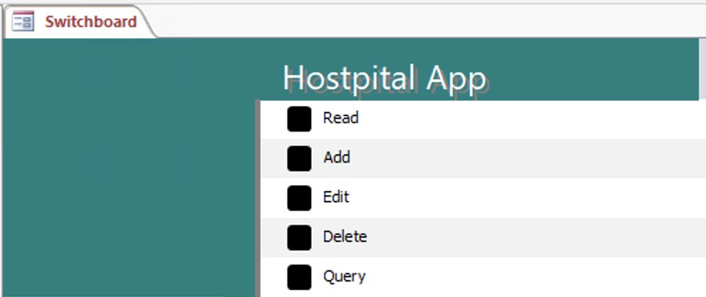

The main switchboard offers multiple sub-switchboards for the user to select from, each designed to help them complete a specific task.

## 

## 

## 

## Read Sub-switchboard

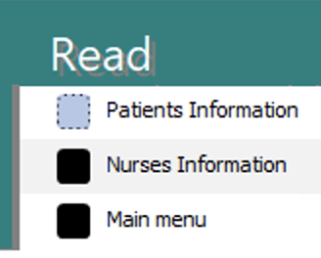

Within the Read tab, the user can click three options. The first option will take you to a read-only version of the report that holds the patient information, the second option to the nurses information report and the third sends you back to the main switchboard.

## Add Sub-switchboard

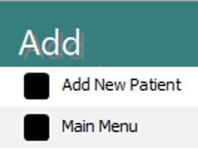

The only available action from here (apart from returning to the main menu) is to "Add New Patient." This option takes you to a form that allows you to enter new patient information into the database. This feature enables the hospital to maintain a record of which patients are currently under their care.

## 

## 

## 

## Edit Sub-switchboard

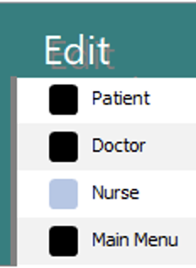

This tab allows the user to edit patient, doctor, or nurse information. Within editing one of the entities you can also undo or save your action.

## Delete Sub-switchboard

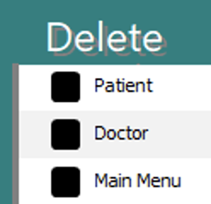

Within this sub-switchboard, the user can delete patients or doctors from the database. This will be used when patients are discharged from the hospital or if a doctor no longer works at the facility.

## 

## 

## 

## 

## Query Sub-switchboard

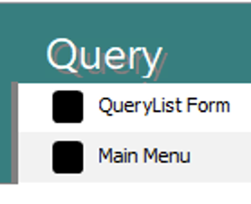

The QueryList Form option takes the user to a tab that looks like this: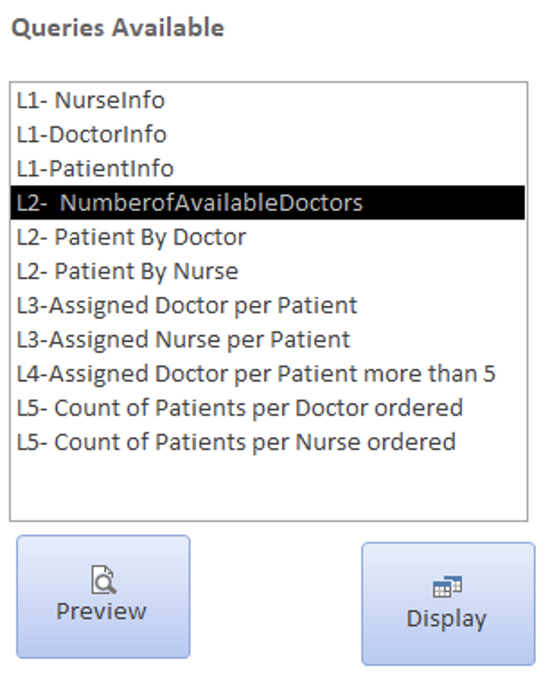

The user can execute the Query by double-clicking it and opening it up, or alternatively, they can select a query with a single click and then choose to preview or display it. The SQL code used for each query is unique and is displayed in the accompanying screenshots. When run, each query generates a distinct output.

### Preview Button:

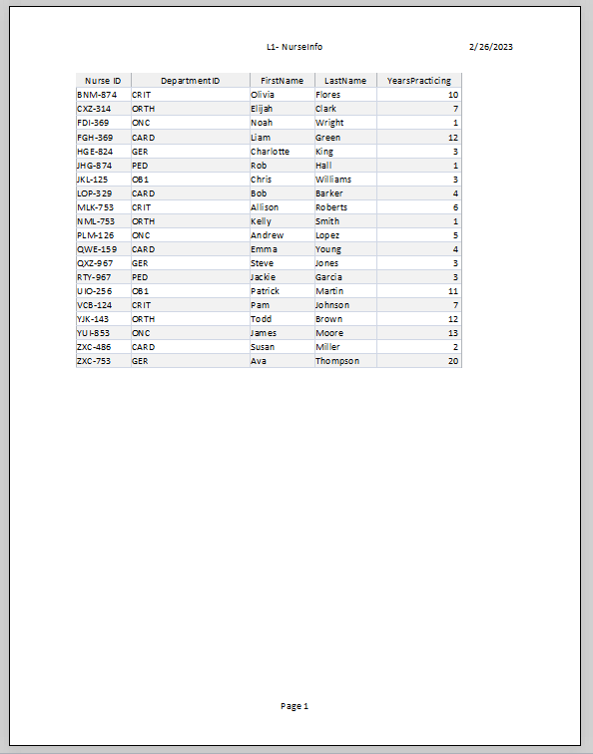

### 

### 

### Display Button:

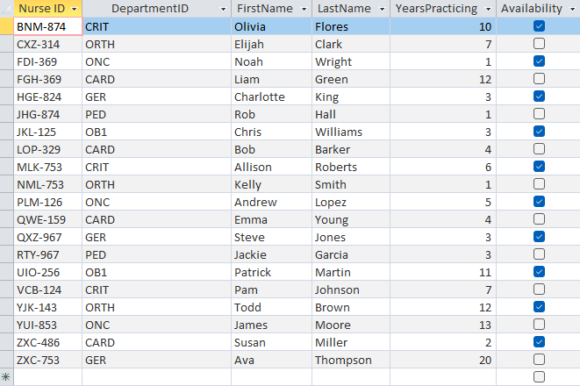

### Level 1 Queries:

**L1-NurseInfo**

SQL code: SELECT *

FROM Nurse;

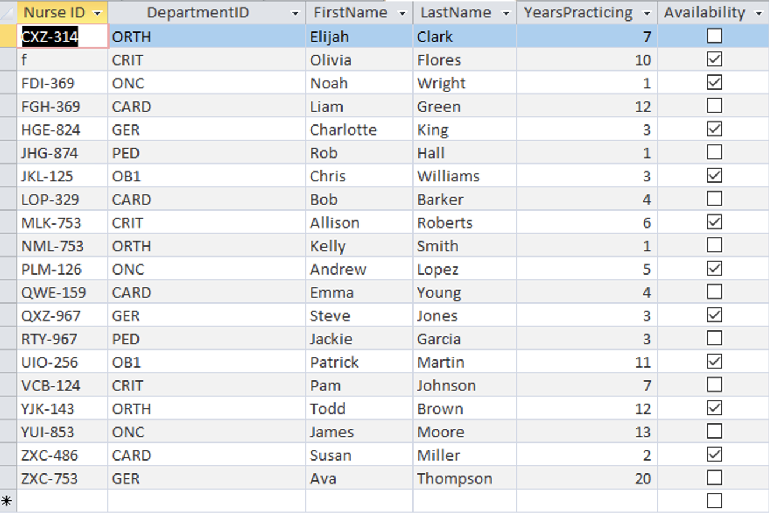

This query allows us to see information on the Nurses.

**L1-DoctorInfo**

SQL Code: SELECT Doctor.DoctorID, Doctor.FirstName, Doctor.LastName

FROM Doctor;

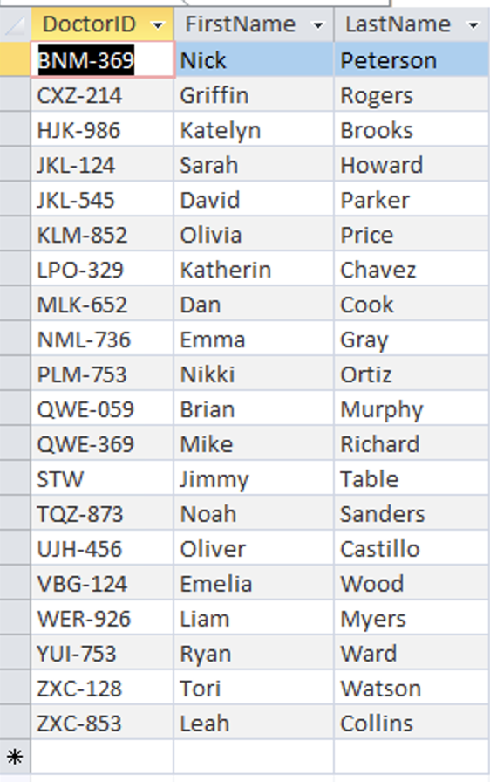

This query allows us to see information on the Doctors.

**L1-PatientInfo**

SQL Code: SELECT Patient.PatientID, Patient.FirstName, Patient.LastName, Patient.Gender, Patient.DOB

FROM Patient;

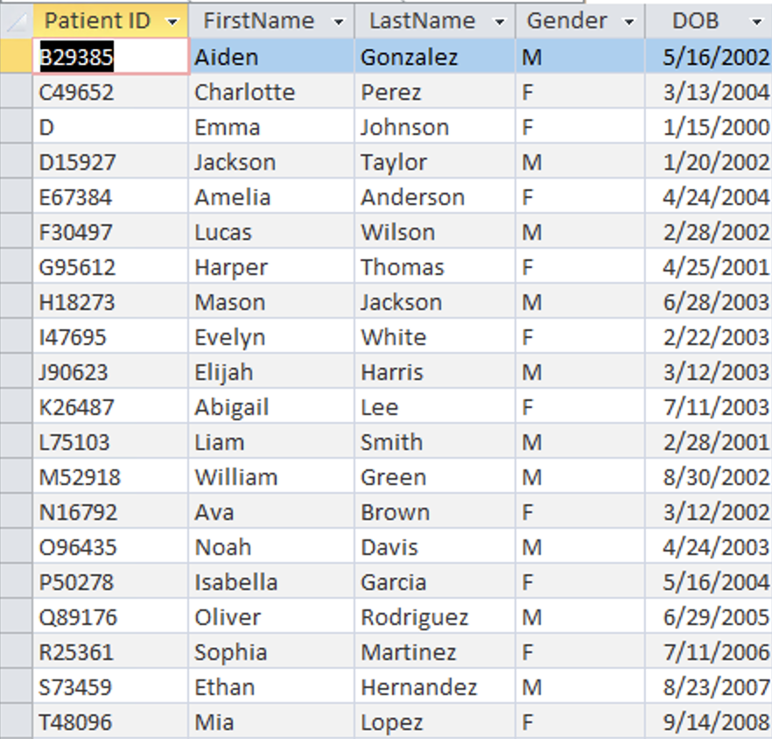

This query allows us to see information on the patients.

### Level 2 Queries:

**L2- Number of Available Doctors**

SQL Code: SELECT Doctor.DoctorID AS DoctorsAvailable

FROM Doctor

WHERE (((Doctor.Availability)=True));

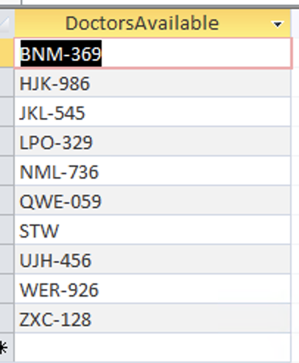

**L2-Patient By Doctor**

SQL Code: SELECT Patient.PatientID, Patient.FirstName, Patient.LastName

FROM Patient

WHERE Patient.DoctorID = "KLM-852";

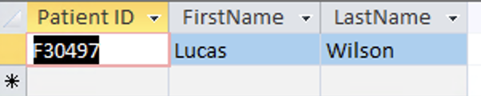

This query produces the output of patients that are assigned to specific doctors by inserting a specific doctor ID in the SQL code.

**L2-Patient By Nurse**

SQL Code: SELECT Patient.PatientID, Patient.FirstName, Patient.LastName

FROM Patient

WHERE Patient.NurseID = "FGH-369";

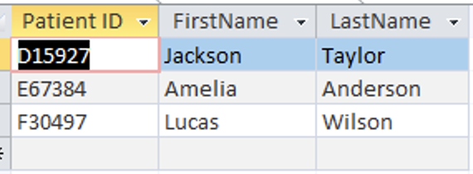

This query produces the output of patients that are assigned to specific nurses by inserting a specific doctor ID in the SQL code.

Level 3 Queries:

**L-3 Assigned Doctor Per Patient**

SELECT Patient.PatientID, Patient.FirstName AS PatientFirstName, Patient.LastName AS PatientLastName, Doctor.FirstName AS DoctorFirstName, Doctor.LastName AS DoctorLastName

FROM Patient INNER JOIN Doctor ON Patient.DoctorID = Doctor.DoctorID;

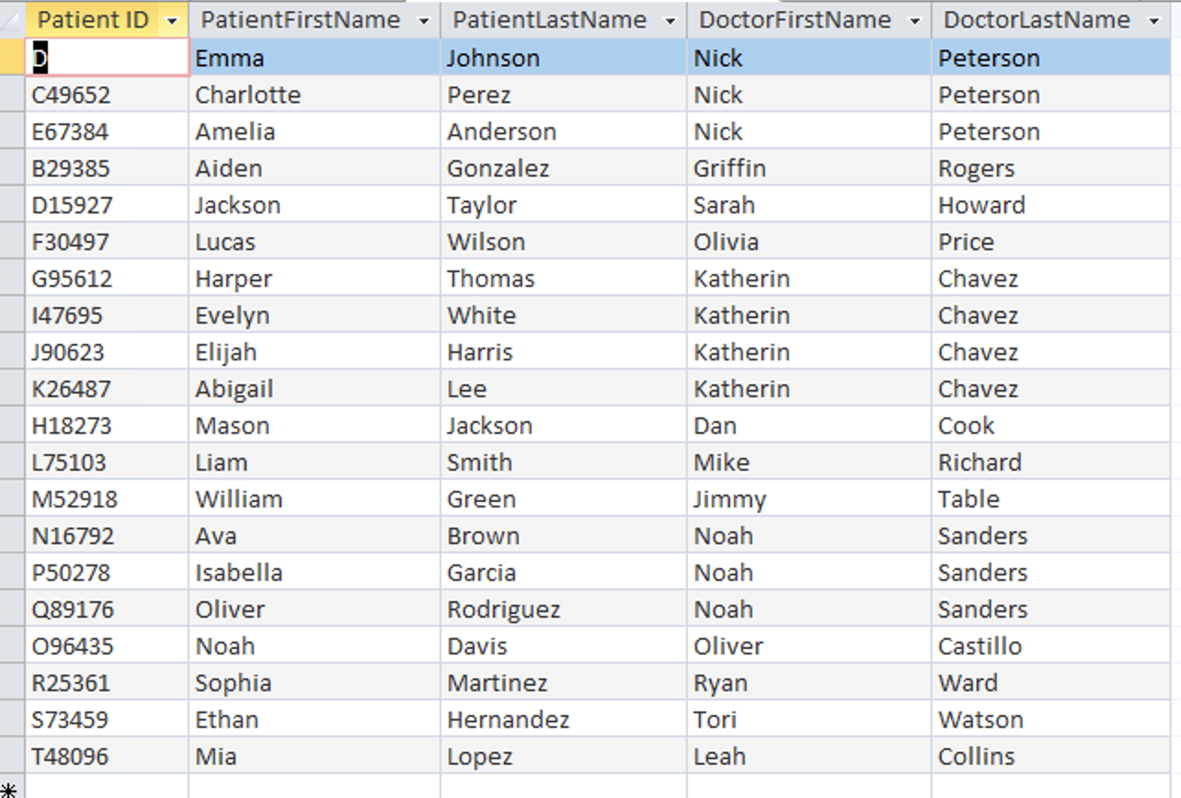

This query produces a table where we can see the names of the patients and which doctor they are assigned too. It allows us to see that certain doctors have more than one patient as well.

**L-3 Assigned Nurse Per Patient**

SQL Code: SELECT Patient.PatientID, Patient.FirstName AS PatientFirstName, Patient.LastName AS PatientLastName, Nurse.FirstName AS NurseFirstName, Nurse.LastName AS NurseLastName

FROM Patient INNER JOIN Nurse ON Patient.NurseID = Nurse.NurseID;

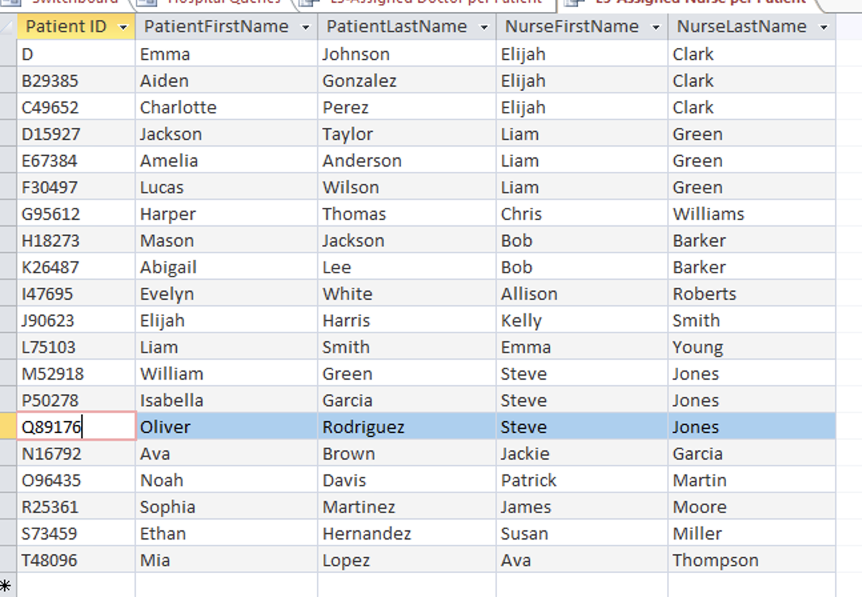

This query produces a table where we can see the names of the patients and which doctor they are assigned too. It allows us to see that certain nurses have more than one patient as well.

### 

### Level 4 Query:

**L4- Assigned Doctor per Patient More than 5 Years Practicing**

SQL Code:SELECT Patient.PatientID, Patient.FirstName AS PatientFirstName, Patient.LastName AS PatientLastName, Doctor.FirstName AS DoctorFirstName, Doctor.LastName AS DoctorLastName

FROM Patient INNER JOIN Doctor ON Patient.DoctorID = Doctor.DoctorID

WHERE Doctor.YearsPracticing >5;

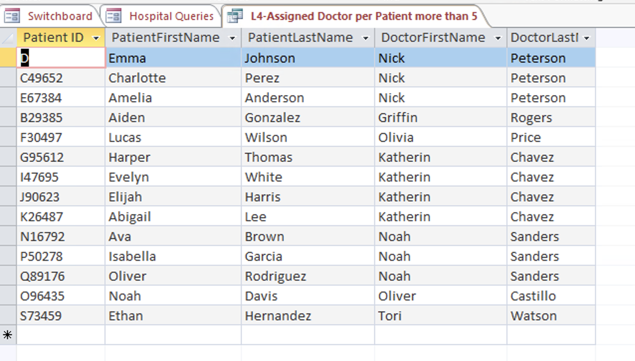

This query shows us an output of the doctors' patients who have been practicing for over five years in their role.

### 

### Level 5 Queries:

**L5- Count of Patients per Doctor Ordered**

SQL Code: SELECT Patient.DoctorID, Doctor.FirstName, Doctor.LastName, COUNT(Patient.DoctorID) AS NumberOfPatients

FROM Patient INNER JOIN Doctor ON Patient.DoctorID = Doctor.DoctorID

GROUP BY Patient.DoctorID, Doctor.FirstName, Doctor.LastName

ORDER BY COUNT(Patient.DoctorID);

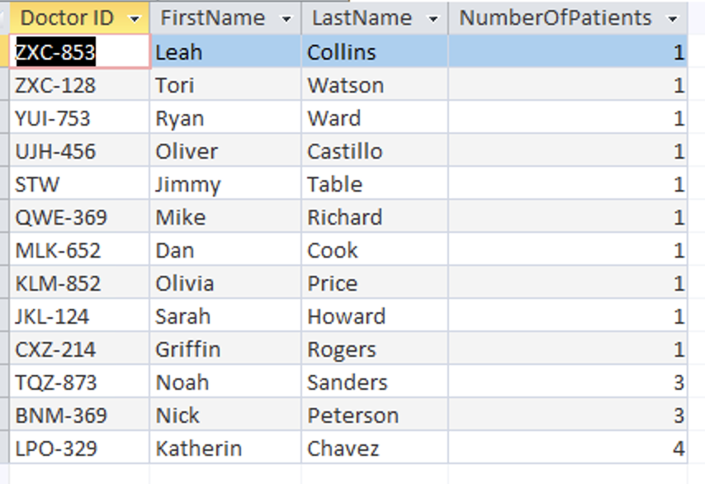

This query outputs the amount of patients each doctor has and includes the doctor's ID along with their full name.

**L5-Count of Patients per Nurse Ordered**

SQL Code: SELECT Patient.NurseID, Nurse.FirstName, Nurse.LastName, COUNT(Patient.NurseID) AS NumberOfPatients

FROM Patient INNER JOIN Nurse ON Patient.NurseID = Nurse.NurseID

WHERE Nurse.YearsPracticing >1

GROUP BY Patient.NurseID, Nurse.FirstName, Nurse.LastName

ORDER BY COUNT(Patient.NurseID);

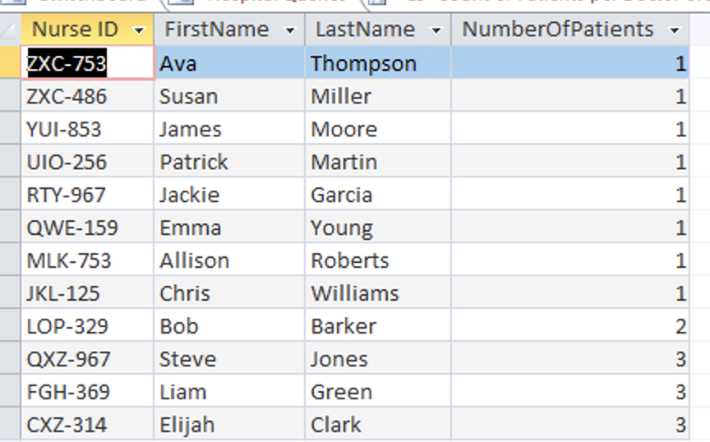

This query outputs the amount of patients each nurse has and includes the nurse’s ID along with their full name.